Party Connections CFP Planning

CFP 1 - Meet the person across the room!
In this CFP, we are interested in using embodied AI to bring people together at social events. Whether a party is big or small, most people show up only knowing a few others there. Someone on the other side of the room might share your hobbies, your major, or the thing you've been wanting to get into, and you'd never know to go talk to them. These are missed connections, and they happen at basically every party.
Apps like Hinge already show that a short profile is enough to make a decent guess about who you'd get along with. Apps like Partiful already handle the guest list and RSVPs. We want to test what happens if you combine the two: guests have a profile built before they arrive, and when they show up, the system tells them who they should try to find. Then, instead of leaving it on a phone screen, a robot (or a wearable) physically helps them make the connection. Romantic matches could come out of this, but our main focus is friendships and relationships that could actually be fruitful.
Working with Galbot, our question is: how do you set up a system that identifies the people who should meet each other at a random party, and how can robots and embodied AI help bring those people together?
What is a Missed Connection? For the purposes of this CFP, a missed connection is when two guests at the same event have a high compatibility score (based on shared interests, hobbies, goals, or background) but never talk to each other during the event. A "good match" is a pair whose profile overlap is high enough that we'd expect them to have a real conversation, not just small talk. Success is not just that two people meet, but that the conversation lasts and they'd want to talk again.

Experimental Setup
We only have a few days to put this together, so the goal is a simple, working prototype rather than a fully fleshed out system. We will host a small party (roughly 15 to 30 guests) in a single open room. Before the event, guests fill out a short questionnaire that acts as their profile. We run a matching step on the responses, and during the party, a small drivable robot guides people to their suggested matches. The team is planning to test three pieces of the system: the matching itself, the robot guide, and a wearable alternative.

A. Profile and Matching
How little information do you need to make a good match? Hinge-style apps work off of a few prompts and preferences, so we want to see how far a short questionnaire can get us. Guests will fill out a Google Form (around 10 questions, under 5 minutes) before the party. In this method, we plan to test:
- Question types (multiple choice interests versus short free-response prompts)
- Number of questions needed before match quality stops improving
- Matching method (simple overlap score versus text embeddings)
- Number of suggested matches per guest (1 versus 3)
Responses will be exported to a spreadsheet and turned into an interest vector for each guest. For multiple choice answers, we'll score pairs by overlap (Jaccard similarity). For free-response answers, we'll use a sentence embedding model and compare guests by cosine similarity. We'll combine these into one compatibility score per pair, then assign matches using maximum weight matching so that everyone gets at least one suggestion and no one person gets sent ten people. The output is a short ranked list per guest, which feeds into the robot and wearable experiments below.

B. Robot Guide
The second part of this CFP explores whether a robot can make the introduction happen in person. Telling someone "go find Alex" on their phone is easy to ignore. Having a robot show up and take you to Alex is harder to ignore and gives both people an icebreaker. Long term, this could run on a Galbot platform, but for the prototype we'll use a small drivable robot.
To test this concept, each guest will wear a name tag with a printed fiducial marker (ArUco or AprilTag). The robot will use an onboard camera to find the tag of the guest it's looking for, approach them, and then lead them to their match. For the first round, the robot will be teleoperated (Wizard-of-Oz), so we can test the social side before worrying about full autonomy. If time allows, we'll add tag-based tracking so the robot can drive to a person on its own. In this experiment, we want to test:
- Do people actually follow the robot, and how far will they go?
- What is the best way for the robot to start the interaction (sound, a screen message, saying the person's name)?
- Does the robot work better leading one person to the other, or bringing both people to a meeting spot?
- How does the robot handle crowded areas and people who are already in a conversation?
Data will be collected as a success rate of introductions attempted versus completed. However, a greater insight would be our qualitative assessment of how guests react. Does it feel fun, or awkward? Do people feel put on the spot?

C. Wearable Method
The final method looks at whether a wearable can do the same job with less overhead than a robot. A robot is one device shared across the whole party, so it can only make one introduction at a time. A wearable works for every guest at once.
Guests will be given a simple wearable, like a badge or wristband with a Bluetooth (BLE) beacon and an LED or vibration motor. When a guest gets close to one of their matches, both wearables light up or buzz. Signal strength (RSSI) between beacons gives us a rough estimate of distance, which is enough to say "your match is nearby" without exact location tracking. The experiment seeks to answer key questions:
- How reliable is BLE distance estimation in a crowded room?
- What is the right distance to trigger the alert?
- Do people go looking for their match after the alert, or ignore it?
The results will be compared against the robot guide to see which approach leads to more completed introductions and which one guests actually enjoy using.

Measuring Success and Consent
To judge whether the system is working, we'll collect data during and after the party:
- Introductions attempted versus completed (did the pair actually talk?)
- Conversation length, logged by a team member or estimated from wearable proximity time
- A short exit survey: did you enjoy the conversation, and would you talk to this person again?
- A follow-up message one week later asking if any matched pairs stayed in touch
We'll also run a few guests without any suggestions as a baseline, so we can compare how often people meet compatible strangers on their own.
Because this involves personal information and physically approaching people, everything is opt-in. Guests choose what goes in their profile, can turn down any suggested match, and can tell the robot or wearable to stop at any time. We will not use face recognition, only the name tag markers guests choose to wear. Profile data stays within the team and gets deleted after the project.

CEP #1: THE SOCIAL BOT
Ereni and JJ
Formal Idea (Long-Term Execution): Guests upload a profile (think dating apps, but we’re intending for this to match friends) about hobbies, location, and music taste. We intend to use AI to match people with similar interests. During a social gathering, people will check in to a robot with a screen, which will suggest several people to talk with and what their interests are. It will also roam around during the party to encourage people to connect. This will be achieved both by increasing group conversation through shared interests as well as connecting people one-on-one. Ideally, there will be a built-in feature that allows the robot to direct people together with features similar to that of FindMy (where the apple watch points with arrows to the location of your missing AirPods, for instance).
- What’s the NEED? What is the question we are trying to answer?
  - Most people arrive at a party only knowing a few others, and usually stay with them the entire time. There may be many people at the event who share similar hobbies, are from hometowns close to one another, or maybe have an obsession with the same niche artist on Spotify. The problem: people walking up to others in a group with no real background or context is either: A) super awkward or B) suggestive
  - Consolidated Need Statement (based on principles from Stanford Biodesign):
  - A way to help guests at social gatherings start conversations with compatible strangers, so that more people have a meaningful conversation with someone new during the event.

- Questions:
  - How little information do we need to make a good match?
  - Which prompts in a questionnaire or profile best predict a good conversation: shared hobbies, "something I want to try", major, or goals?
  - Will guests follow a robot to meet a stranger? What is the best way to encourage people to speak?
  - Does a robot-made introduction lead to better conversations than meeting on their own?
CEP Idea:
  - Hypothesis: Most guests (60% or more) will respond to the robot. Matched pairs the robot introduces will talk longer and rate the conversation higher than matched pairs who are left to meet on their own.
  - Prototype: a Roomba/ Amazon Remote Controlled Robot with a cardboard shell and a phone on FaceTime as its face (showing the guest’s name and an arrow). It’s Wizard-of-Oz: one hidden teammate voices it, one drives it with the Roomba app, and two observe.

Version 1 (roomba) | Version 2 (Controlled Robot)
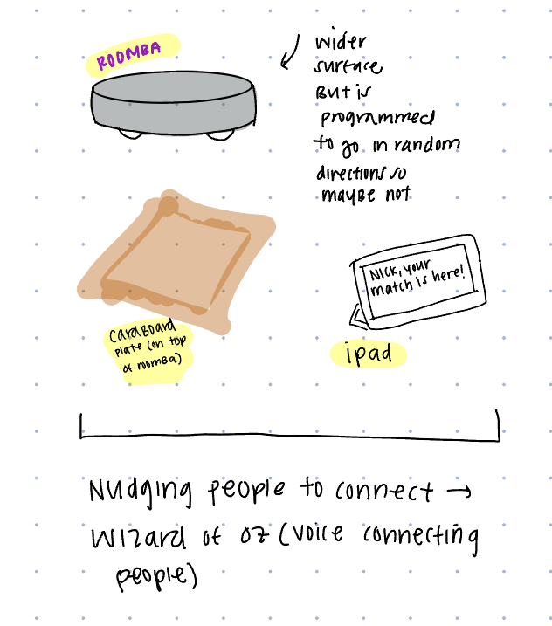 | 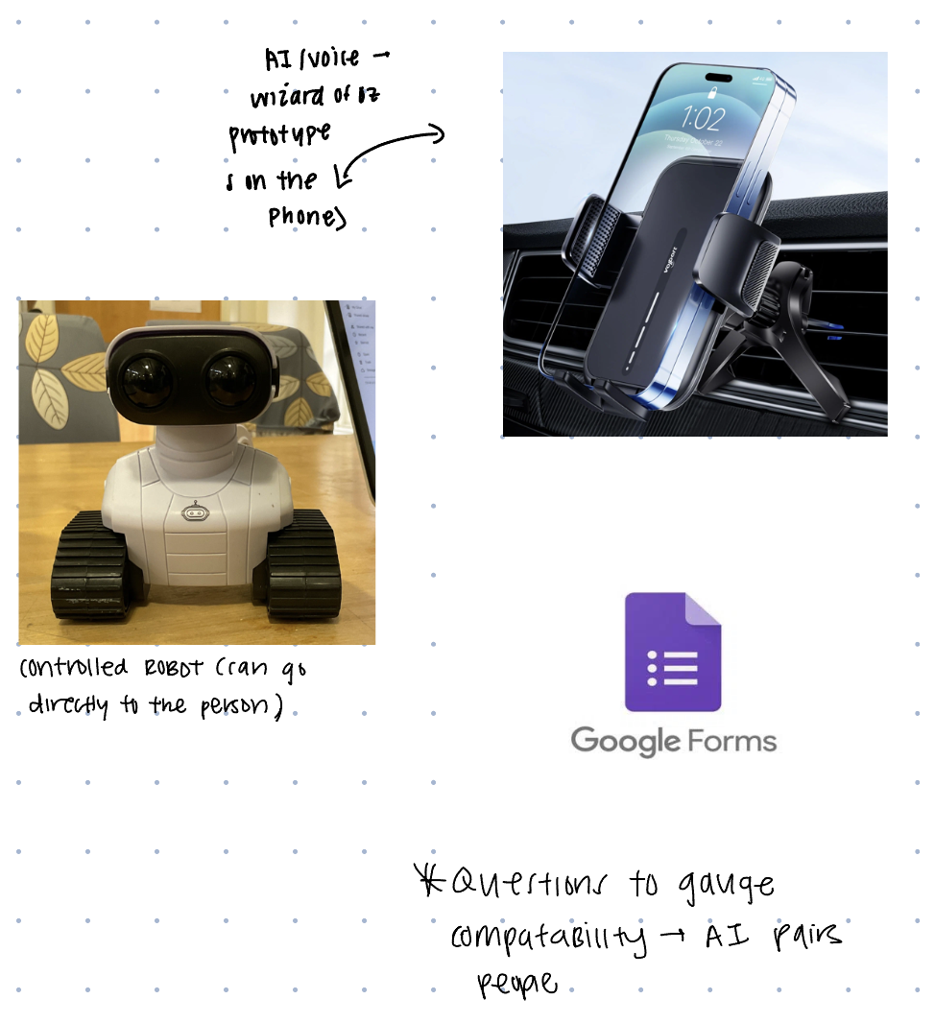
** intend to manually control (or guide roomba) to people in a room, using our voices to connect people. We’ll measure how long they speak for as a measure of “meaningful conversation”
Methodology:
1. Pre-party form. Send a short Google Form (about 10 questions, under 5 minutes) with the invite (everyone has to fill it out). It asks about hobbies, major, hometown, music taste, “something I’ve wanted to try,” and “my ideal Saturday.”
2. Matching. AI will read the responses and find people who have a good potential for friendship. For every connection, they get a one-line reason (“both climb and shoot film”) and a 1–5 rating on strength of match. A score of 4-5 indicates best potential for friendship (select these as pairs).
3. Assign groups. Randomly choose robot group and control group:
- Robot group: the robot introduces these participants to potential friends during the party.
- Control group: the participant gets no introduction, to see whether people meet new people and make connections without assistance.
4. Arrival. At the door, every guest is told: “A robot may come find you tonight to introduce you to someone new. If it does, please follow it and go say hi.” Guests get a name tag so the robot operators and observers can identify them.
5. Robot introductions. One hidden teammate drives the robot and another voices it through the phone on its face. The robot finds the first guest (“Hi Maya! Someone here also climbs and shoots film. Follow me!”), leads them to the second guest, introduces them by name and shared interest, shows a starter question on screen, and leaves after about 15 seconds.
6. Observation. An observer records:
- whether each robot-group guest agreed to follow the robot,
- how long each robot-introduced conversation lasted,
- whether control-group pairs talked at all during the party, and if so, for how long.
7. Exit survey. As guests leave, everyone fills out a short survey asking how many new people they met, how much they enjoyed meeting new people (1–5), the strength of connections, and if they will see anyone again (exchanged contact info, etc). For the robot group, we will also ask whether the robot felt fun or creepy.
8. Analysis. Compare the two groups on how many pairs actually talked, how long their conversations lasted, their enjoyment ratings, and if they planned on staying in touch (i.e. exchanged contact info, instagram, etc). Also check whether the team’s 1–5 match ratings predicted which pairs talked longest.
- Future Work:
  - Interview students about what they'd be comfortable sharing on a pre-party form, and how they'd feel getting a "your match is ready" text.
  - Decide if the robot should interact unprompted, or if people should ping the robot to help them meet new people
  - Determine if people feel a sense of social guilt with the robot or if it’s easy to ignore

Other info (Needs Finding from 10/29 SGM): https://docs.google.com/document/d/18Hiias5H7MXnZQdZ05eT0OKo5izFA6AG3rp0i2gV2uE/edit?tab=t.0

